DEPARTMENT OF NATURAL SCIENCES
LESSON PLAN
NAME OF TEACHER: ……………………… DATE:
SUBJECT: Mathematics DURATION:80 MINUTES
TOPIC: Identify and create loops in flow charts CLASS: 9
SUBTOPIC: Loops NO OF BOYS…
GIRLS…
REFERENCES: Excell and advance iin mathematics book 9 and progress in mathematics book 9
TEACHING LEARNING /AIDS: learners book, chalk board and chart
RATIONALE: This lesson is on looping, Teacher exposition discussion and question and answer methods will be used. This lesson will develop learners knowledge about Basic programming ( Writing simple computer programmes).The skill of Application of flow charts to real life.The value of Logical thinking in constructing flow charts.
LEARNING OUTCOMES: L.S.B.A.T:
- Identify and create loops in flow charts
PREREQUISITE KNOWLEDGE: Learners have ideas about the topic being taught.
LESSON INTRODUCTION: Brainstorming questions about the topic being taught will be used to introduce the topic and to revise through the previous lesson
LESSON DEVELOPMENT
CONTENT | TEACHER’S ACTIVITY | PUPIL’S ACTIVITY | METHODS
B. The IF………….THEN ………..ELSE statement is used if only two option are available .its structure is as shown below  IF<Condition>THEN  Statement (s)  ELSE  Statement (s)  ENDIF  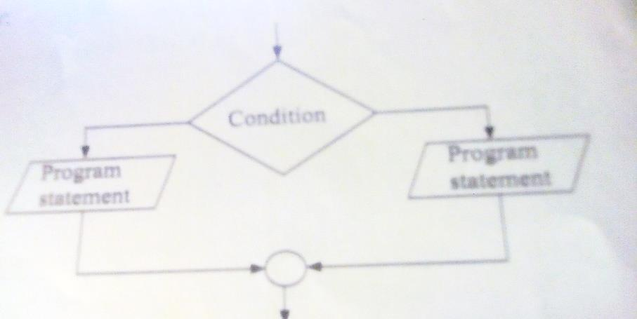  EXAMPLE  Write the pseudocode and draw the flow diagram for a program that displays pass when the score is greater than 40 and fail when it is 40 or below  SOLUTION  IF Score>40 THEN  Print”pass  ELSE  Print “fail;’  ENDIF  pseudocode  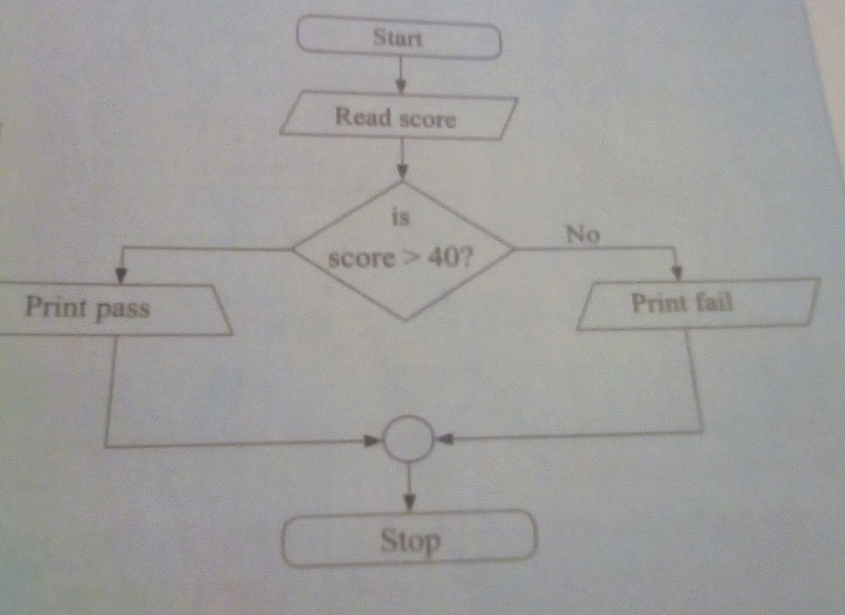 | Teacher to explain about the IF………….THEN ………..ELSE statement  Teacher to write the example on the board  Teacher to solve on the board | Learners to listen attentively  Learners to write the example in their example books  Learners listens attentively | Teacher exposition  Demonstration
Lesson conclusion: Tr to conclude lesson by revising through the lesson with leaners to help remedial learners
Learners evaluation: ………………………………………………………………………………………………………………………………………………………………………………………………………………………………………………………………………………………………………………………………………………………………………………………………………………………………………………………………
Teachers evaluation:
………………………………………………………………………………………………………………………………………………………………………………………………………………………………………………………………………………………………………………………………………………………………………………………………………………………………………………………………

